MEDTRONIC PAYMENT REMITTANCE

The below screenshot contains an example of the payment remittance advice. In order to receive this notification, please check the appropriate box on the enrollment form and provide a valid email address.

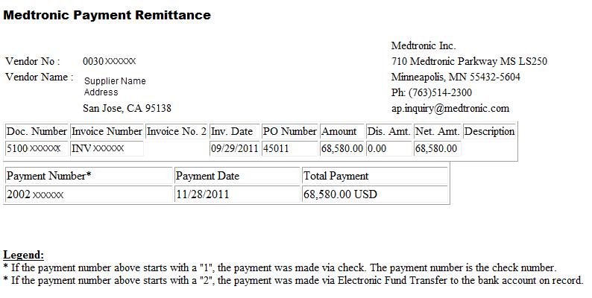

MEDTRONIC ELECTRONIC PAYMENT ENROLLMENT FORMS

Suppliers can sign up with Medtronic by simply filling out the appropriate form and sending to their Medtronic Contact. If there is no Medtronic Contact, the form can be faxed to 651-367-0436 or sent via email to rs.usvendormaster@medtronic.com.

